SIMATS ENGINEERING

ASSESSMENT TOOL 1

COURSE NAME: Database Management Systems COURSE CODE: CSA0501

COURSE OUTCOME COVERED

CO1: Analyze DBMS architecture, different data models, schema types, and design ER/EER diagrams, relational schemas for case-based scenarios by identifying entities and relationships. (BL1, BL2)

Activity Tool : Short Answer Text(High) Assessment Tool Weightage: 30%

Dr

QUESTIONS |  | Total Marks: 50
Q.No | Question | Bloom's Level | Marks
1 | UPS Product Tracking Information System | BL1 – | 5
 |  | Remember
 | UPS prides itself on having up-to-date information on the processing and current location of each shipped item. To do this, UPS relies on a company-wide information system. Shipped items are the heart of the UPS product tracking information system. Shipped items can be characterized by item number (unique), weight, dimensions, insurance amount, destination, and final delivery date. Shipped items are received into the UPS system at a single retail center. Retail centers are characterized by their type, uniqueID, and address. Shipped items make their way to their destination via one or more standard UPS transportation events (i.e., flights, truck deliveries). These transportation events are characterized by a unique scheduleNumber, a type (e.g, flight, truck), and a deliveryRoute. Create an Entity Relationship diagram that captures this

 | information about the UPS system.
2 | Course Management System  Consider a university database for the scheduling of classrooms for final exams. This database could be modeled as the single entity set exam, with attributes course-name, section-number, room-number, and time. Alternatively, one or more additional entity sets could be defined, along with relationship sets to replace some of the attributes of the exam entity set, as  - course with attributes name, department, and c-number  - section with attributes s-number and enrollment, and dependent as a weak entity set on course  - room with attributes r-number, capacity, and building Show an E-R diagram illustrating the use of all three additional entity sets listed. | BL2 –  Understand | 5
3 | University Registrar’s Office Management System  A university registrar’s office maintains data about the following entities:  - courses, including number, title, credits, syllabus, and prerequisites;  - course offerings, including course number, year, semester, section number, instructor(s), timings, and classroom;  - students, including student-id, name, and program;  - instructors, including identification number, name, department, and title.  - Further, the enrollment of students in courses and grades awarded to students in each course they are enrolled for must be appropriately modeled.  Construct an E-R diagram for the registrar’s  office. | BL2 –  Understand | 5
4 | Hospital Management System  Construct an E-R diagram for a hospital with a set of patients and a set of medical doctors.  Associate with each patient a log of the various tests | BL2 –  Understand | 5

and examinations conducted. Construct appropriate tables for the above ER Diagram :
Patient(SS#, name, insurance) Physician ( name, specialization) Test-log( SS#, test-name, date, time) Doctor-patient (physician-name, SS#) Patient-history(SS#, test-name, date)
5 | Company Project Management System  Construct an ER Diagram for Company having following details :  Company organized into DEPARTMENT. Each department has unique name and a particular employee who manages the department. Start date for the manager is recorded. Department may have several locations.  A department controls a number of PROJECT. Projects have a unique name, number and a single location.  Company’s EMPLOYEE name, ssno, address, salary, sex and birth date are recorded. An employee is assigned to one department, but may work for several projects (not necessarily controlled by dept). Number of hours/week an employee works on each project is recorded; The immediate supervisor for the employee.  Employee’s DEPENDENT are tracked for health insurance purposes (dependentname, birthdate, relationship to employee). | BL2 –  Understand | 5
6 | Explain schema and instance with examples. Distinguish between logical schema, physical schema, and view schema. | BL1 –  Remember | 5
7 | Identify the entities, attributes, and relationships for a Bank Management System and construct its ER diagram. | BL2 –  Understand | 5
8 | Explain the Extended ER (EER) model. Describe the concepts of generalization, specialization, and aggregation. | BL2 –  Understand | 5
9 | Design an EER diagram for a Hospital Management | BL2 – | 5

 | System incorporating inheritance and weak entities. | Understand
10 | Explain the role of a DBA (Database Administrator) and the responsibilities associated with the position. | BL1 –  Remember | 5

Code of Conduct:

I (Name / Reg No) certify that this submission is my original work and that I have adhered to the guidelines specified for this assessment. I understand that any violation of academic integrity rules will result in disciplinary action.

Signature of the student:

RUBRICS FOR CALCULATION:

Criteria | Weightage | Level 4 (Exemplary) | Level 3 (Proficient) | Level 2 (Developing) | Level 1 (Beginning)
Concept Identification | 30% | Demonstrates clear and complete understanding of the concept | Good understanding with minor gaps | Basic understanding with some misconceptions | Poor or incorrect understandin g
Linkages | 25% | Completely correct answer with no errors | Mostly correct with minor errors | Partially correct with noticeable errors | Incorrect or irrelevant answer
Organization | 20% | Correctly applies concepts to solve  the question/problem | Applies concepts with minor mistakes | Limited or partially correct application | No or incorrect application
Integration of Literature | 15% | Covers all required parts of the question | Covers most parts with minor omissions | Covers only some parts | Incomplete or missing response
Clarity | 10% | Clear, concise, and well- | Understandabl e with minor | Somewhat unclear or | Difficult to understand

 |  | organized answer | issues | poorly structured

ANSWER:

Entities and Attributes

1. Shipped_Item
- itemNumber (PK)
- weight
- dimensions
- insuranceAmount
- destination
- finalDeliveryDate
- retailCenterID (FK)

2. Retail_Center
- uniqueID (PK)
- type
- address

3. Transportation_Event
- scheduleNumber (PK)
- type (Flight/Truck)
- deliveryRoute

4. Shipment_Transport (Associative Entity)
- itemNumber (FK)
- scheduleNumber (FK)
- sequenceNo (Order of transportation)

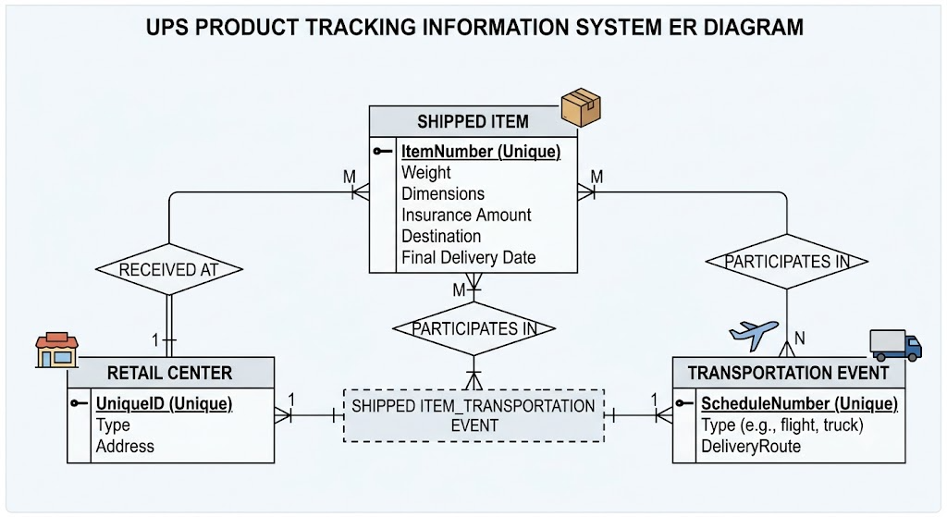

- ANSWER

Here is the core database theory explaining the design of this Course Management System, tailored for a 3-mark exam question:

1. Weak Entity Set and Identifying Relationship (1 Mark)
- Concept: A weak entity set is an entity that does not possess sufficient attributes to form a primary key on its own. It depends on a dominant identifying owner entity set to exist.
- Application: section is a weak entity set dependent on the strong entity course. A section cannot exist without a course, and its primary key is a combination of the course's primary key (c-number) and its own partial key (s-number). This dependency is represented by a double-diamond relationship (Is Section Of).

2. Multi-way (Ternary/N-ary) Relationship Set (1 Mark)
- Concept: Instead of breaking real-world interactions into separate, disconnected binary pairs, an n-ary relationship binds three or more entities together simultaneously to capture a unified event.
- Application: The central Is Scheduled For relationship is a ternary/quaternary relationship. It links course, section, room, and time to a specific exam. This ensures that a final exam is scheduled for a specific section of a course, inside a designated room, at a precise time slot, preventing scheduling conflicts.

3. Structural Constraints (Cardinality & Participation) (1 Mark)
- Concept: Cardinality ratios ($1:1$, $1:N$, $M:N$) express the number of entities to which another entity can be associated via a relationship set. Participation constraints (total vs. partial) specify whether the existence of an entity depends on its being related to another entity via the relationship set.
- Application: The structural lines indicate how many components mix to form an exam. For instance, a single room (1) can host multiple scheduled exam sections ($N$), while a specific section belongs to exactly one identifying course (total participation, denoted by the double line/double rectangle for the weak entity).
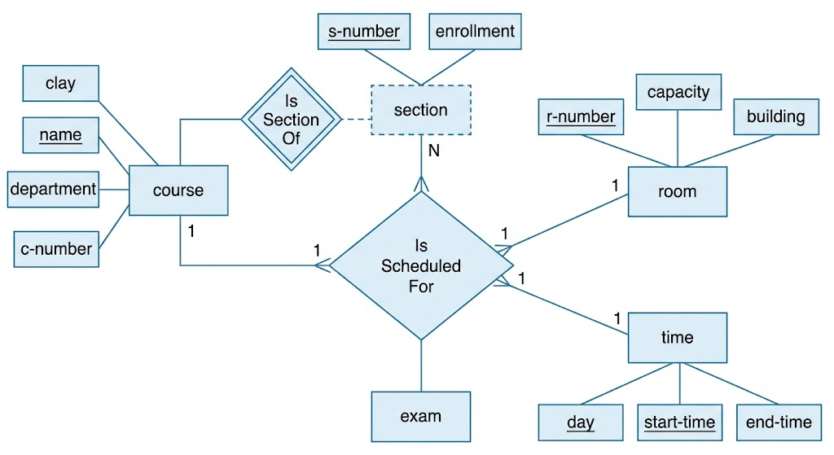

3.ANSWER

Here is a breakdown of the University Registrar's E-R diagram, written in a clear, human-centered way.

1. Core Entities (The "Nouns")
- Courses: The master catalog entries. Each course has a unique Course Number, along with its Title, Credits, and a Syllabus.
- Course Offerings: The actual classes scheduled in a specific semester. Since an offering cannot exist without a parent course, it relies on Course Number (as a Foreign Key), combined with Year, Semester, and Section Number to define a specific class instance. It tracks details like Timings and the assigned Classroom.
- Instructors: The faculty members teaching the classes. They are tracked by a unique Identification Number, their Name, Department, and academic Title.
- Students: The individuals taking the classes, identified by a unique Student-ID, their Name, and their academic Program (e.g., B.Tech, M.S.).

2. Key Relationships (The "Verbs")

Course & Course Offerings (IS_OFFERING_OF)
- Type: One-to-Many ($1:N$)
- Logic: A single master Course can have multiple Course Offerings across different semesters and years, but a specific class section belongs to exactly one parent course.

Instructors & Course Offerings (TEACHES)

3. Handling Enrollments & Grades
- The Connection: A student can enroll in multiple class sections, and a single class section will host many students.
- The Grade Placement: The Grade attribute cannot live purely on the student entity (a student has many grades) or on the course offering entity (a class has many student grades). It lives precisely on the Enrollments bridge because a grade is only generated when a specific student completes a specific course offering.

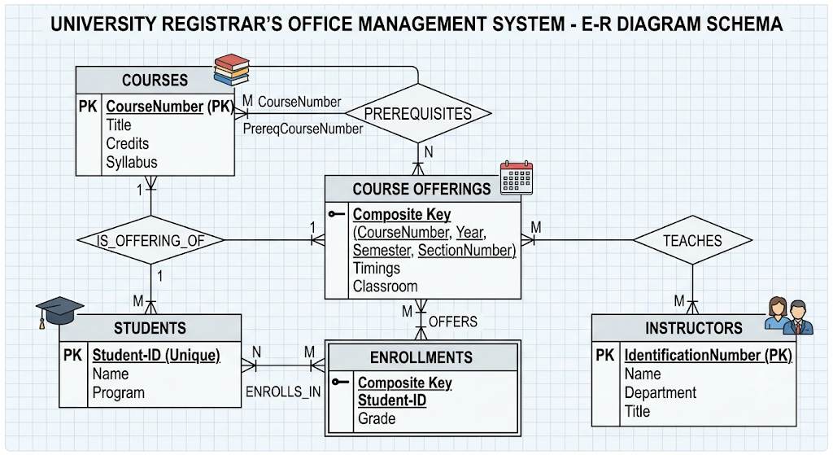
- ANSWER
Here is the database design theory for the Hospital Management System, mapping the ER model directly to the schema tables as per standard database design principles:

1. Strong Entities and Primary Keys
- Patient: This is a strong entity set because it contains an independent unique identifier: SS# (Social Security Number). It maps directly to its own table with SS# as the primary key.
- Physician: Another strong entity set identified by the unique name of the medical doctor. It maps to the Physician table with physician-name acting as the primary key.

2. Weak Entity Sets and Dependency
- Test-log: A log of tests cannot exist without a patient to whom those tests belong. Therefore, Test-log is modeled as a weak entity set that depends on the strong owner entity Patient.
- Key Formation: Because it is a weak entity, it doesn't have a full primary key of its own. It borrows SS# from the Patient table and combines it with its own partial keys (test-name, date, time) to establish a unique record.

3. Many-to-Many ($M:N$) Relationships
- Doctor-Patient Interaction: A single doctor can treat multiple patients, and a single patient can be under the care of multiple specialist physicians. This forms an $M:N$ relationship.
- Relational Mapping: In a relational database, an $M:N$ relationship cannot be embedded inside the existing entity tables. Instead, it must be broken out into its own junction table—Doctor-patient—which consists of the primary keys from both connecting tables (physician-name, SS#) acting as a composite primary key.

4. Derived Schema Tables
Based on these theoretical rules, the system's operational tables are constructed as follows:
Table Name | Attributes | Key Constraints / Role
Patient | SS#, name, insurance | SS# is the Primary Key (PK).
Physician | physician-name, specialization | physician-name is the Primary Key (PK).
Test-log | SS#, test-name, date, time | SS# acts as a Foreign Key (FK) referencing the Patient table. Together, all attributes form a composite key.
Doctor-patient | physician-name, SS# | Junction table mapping the $M:N$ relationship. Both act as a composite PK.
Patient-history | SS#, test-name, date | A historic slice derived from the Test-log tracking clinical timelines.

5.ANSWER

Here is the database design theory for the Company Project Management System (often referred to as the classic Elmasri-Navathe company database model), tailored to explain how the business logic converts to an ER structure.

1. Strong Entities and Their Key Structural Roles
- Employee: A strong entity set uniquely identified by ssno (Social Security Number). It serves as the central hub of the company, connecting to departments, projects, and dependents.
- Department: A strong entity set uniquely identified by its name.
  - Multi-valued Attribute: Since a department can have several locations, locations is modeled as a multi-valued attribute (represented by a double oval in traditional ER diagrams), which maps to a separate table in a relational database to prevent repeating groups.
- Project: A strong entity set with a unique name and number. It has a single-valued attribute location.

2. Weak Entity Set
- Dependent: This entity tracks family members for health insurance purposes. It is a weak entity set because a dependent cannot exist in the database without being tied to an active employee.
- Key Formation: It lacks a standalone primary key. It utilizes dependentname as a partial key (discriminator) alongside the primary key of its identifying owner (ssno from Employee) via an identifying relationship (traditionally represented by a double diamond).

3. Advanced Relationship Sets and Structural Constraints

The Managing & Supervising Hierarchies
- Manages (Department to Employee): A $1:1$ relationship. A department has exactly one manager, and an employee can manage at most one department. This relationship features a descriptive attribute called start_date, which records exactly when the employee took over the managerial role.
- Supervises (Recursive Relationship): This is a unary/recursive relationship on the Employee entity set. It represents a $1:N$ hierarchy where an "immediate supervisor" (1) manages multiple subordinate "employees" ($N$).

Project and Assignment Dynamics
- Controls (Department to Project): A $1:N$ relationship. A single department can control a number of projects, but each project is controlled by exactly one single department.
- Works_On (Employee to Project): A Many-to-Many ($M:N$) relationship. An employee can work on multiple projects, and a project can employ many workers.
  - Relationship Attribute: The attribute hours/week belongs directly to this $M:N$ relationship interface because hours cannot be attributed to just an employee or just a project independently; it is a measure of their interaction.

4. Logical Table Schema Mapping
Based on the ER theory detailed above, the relational tables are derived as follows:
Table Name | Attributes (* = Primary Key, ** = Foreign Key)
Employee | ssno*, name, address, salary, sex, birthdate, dno** (Dept No), supervisor_ssno**
Department | name*, manager_ssno**, manager_start_date
Dept_Locations | dept_name***, location* (Handles the multi-valued attribute)
Project | number*, name, location, controlling_dept**
Works_On | employee_ssno**, project_number**, hours_per_week
Dependent | employee_ssno***, dependent_name*, birthdate, relationship

6.ANSWER

1. Schema and Instance
Schema:
The schema is the blueprint or structure of a database. It defines tables, columns, data types, and relationships.
Example:
Student(Student_ID, Name, Department, Age)
Instance:
An instance is the actual data stored in the database at a particular time.

Example:
Student_ID | Name | Department | Age
101 | Rahul | CSE | 20
102 | Priya | ECE | 21

2. Difference Between Logical, Physical, and View Schema
Logical Schema | Physical Schema | View Schema
Defines the logical structure of the database. | Describes how data is stored on disk. | Defines what data each user can see.
Includes tables and relationships. | Includes files, indexes, and storage methods. | Shows only required data to users.
Example: Student(ID, Name, Dept) | Example: Index on Student_ID. | Example: Student view hides salary information.

7.ANSWER

Bank Management System – ER Diagram

Entities and Attributes
- Customer
  - Customer_ID (PK)
  - Name
  - Address
  - Phone
- Account
  - Account_No (PK)
  - Account_Type
  - Balance
- Branch
  - Branch_ID (PK)
  - Branch_Name
  - Location
- Loan
  - Loan_ID (PK)
  - Loan_Amount
  - Loan_Type

Relationships
- Customer → Owns → Account (1:M)
- Branch → Maintains → Account (1:M)
- Customer → Takes → Loan (1:M)
- Branch → Issues → Loan (1:M)

ER Diagram (Text Form)
+-----------+ Owns +-----------+
| Customer |1 ------------ M | Account |
+-----------+ +-----------+
| Customer_ID| | Account_No|
| Name | | Type |
| Address | | Balance |
| Phone | +-----------+
+-----------+
^
|
Maintains (1:M)
|
+-------------+
| Branch |
+-------------+
| Branch_ID |
| Branch_Name |
| Location |
+-------------+

+-----------+ Takes +-----------+
| Customer |1 ------------ M | Loan |
+-----------+ +-----------+
| Loan_ID |
| Amount |
| Type |
+-----------+
^
|
Issues (1:M)
|
+-------------+
| Branch |
+-------------+
PK = Primary Key
8.ANSWER

Extended ER (EER) Model
The Extended Entity-Relationship (EER) model is an extension of the ER model that includes advanced concepts such as generalization, specialization, and aggregation. It is used to represent complex real-world relationships more accurately.

1. Generalization
- Combines two or more lower-level entities into a higher-level superclass based on common attributes.
- It follows a bottom-up approach.
Example:
- Savings Account and Current Account → Account

2. Specialization
- Divides a higher-level entity into lower-level subclasses based on specific characteristics.
- It follows a top-down approach.
Example:
- Employee → Manager, Clerk, Cashier

3. Aggregation
- Treats a relationship between entities as a higher-level entity so it can participate in another relationship.
- Used when a relationship itself needs to be associated with another entity.
Example:
- Employee works on Project is treated as an aggregate entity and related to Manager who supervises the work.
9.ANSWER

EER Diagram for Hospital Management System

Entities
Person (Superclass)
- Person_ID (PK)
- Name
- Address
- Phone
Specialization (Inheritance)
- Doctor: Doctor_ID, Specialization
- Patient: Patient_ID, Disease
Hospital
- Hospital_ID (PK)
- Hospital_Name
- Location
Appointment (Weak Entity)
- Appointment_No (Partial Key)
- Date
- Time

Relationships
- Person → Doctor, Patient (Inheritance / Specialization)
- Doctor → Treats → Patient (1:M)
- Hospital → Employs → Doctor (1:M)
- Patient → Has → Appointment (1:M) (Appointment is a weak entity and depends on Patient.)

EER Diagram (Text Form)
Person
(Person_ID, Name, Address, Phone)
|
-----------------------
| |
Doctor Patient
(Doctor_ID, Specialization) (Patient_ID, Disease)
| |
Treats (1:M) --------------|
|
Hospital
(Hospital_ID, Name, Location)
|
Employs (1:M)
|
Doctor

Patient (1:M)
|
| Has
|
<<Weak Entity>>
Appointment
(Appointment_No, Date, Time)
Features used:
- Inheritance (Specialization): Person → Doctor, Patient
- Weak Entity: Appointment (depends on Patient)
- Relationships: Employs, Treats, Has
10. ANSWER

Role of a Database Administrator (DBA)
A Database Administrator (DBA) is responsible for managing, maintaining, and securing the database to ensure it operates efficiently and reliably.

Responsibilities of a DBA
- Database Installation and Configuration – Installs and configures the DBMS.
- Database Design – Creates and maintains database structures.
- Security Management – Controls user access and protects data.
- Backup and Recovery – Performs regular backups and restores data after failures.
- Performance Monitoring – Optimizes database performance and resolves issues.
- Data Integrity – Ensures data is accurate and consistent.
- Storage Management – Allocates and manages database storage.
- Maintenance – Updates, patches, and monitors the database system.

Summary
A DBA ensures the database is secure, reliable, available, and performs efficiently while managing backups, recovery, user access, and maintenance.

Top of Form
Bottom of Form

